
Direct Deposit Enrollment Form Company: _______ _________________

To enroll in Direct Deposit, simply fill out this form and give it to your payroll manager with a voided check for each checking account – NOT A DEPOSIT SLIP. If depositing to a savings account, ask your bank to give you the Routing/Transit Number for your account. It isn’t always the same as the number on a savings deposit slip. This will help ensure that you are paid correctly.

Below is a sample check detailing where the information necessary to complete this form can be found.
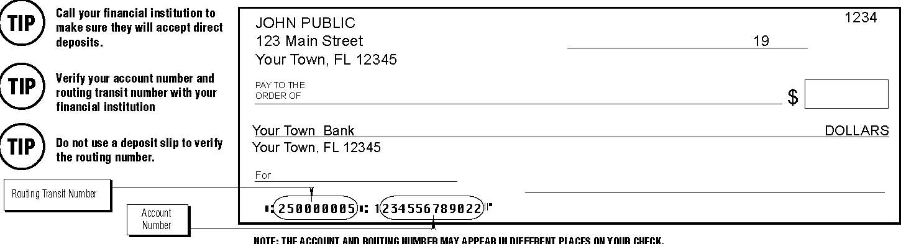

ACCOUNT INFORMATION
You may choose up to three accounts below. (Your last item must be for the remaining amount owed to you.)

- Bank Name, City, State: __________________________________________________________________

Routing/Transit Number (9 digits): ___ ___ ___ ___ ___ ___ ___ ___ ___

Account Number: _________________________________________

Type of account: Checking Savings I wish to deposit $___________ OR Entire Net Amount

- Bank Name, City, State: __________________________________________________________________

Routing/Transit Number (9 digits): ___ ___ ___ ___ ___ ___ ___ ___ ___

Account Number: _________________________________________

Type of account: Checking Savings I wish to deposit $___________ OR Entire Net Amount

- Bank Name, City, State: __________________________________________________________________

Routing/Transit Number (9 digits): ___ ___ ___ ___ ___ ___ ___ ___ ___

Account Number: _________________________________________

Type of account: Checking Savings I wish to deposit $___________ OR Entire Net Amount
PLEASE READ AND SIGN BELOW BEFORE SUBMITTING:

I hereby authorize my employer (hereinafter “Company”) to deposit any amounts owed by my initiating credit entries to my accounts at the financial institutions (hereinafter “Bank”) indicated on both sides of this form. Further, I authorize Bank to accept and to credit any credit entries indicated by Company to my accounts. In the event that Company deposits funds erroneously into my account, I authorize Company to debit my account for an amount not to exceed the original amount of the erroneous credit.

This authorization is to remain in full force and effect until Company and Bank have received written notice from me of its termination in such time and in such manner as to afford Company and Bank reasonable opportunity to act on it.

Name: ___________________________________ Social Security Number: ___________________________

Signature: ____________________________________________ Date: ____________________

